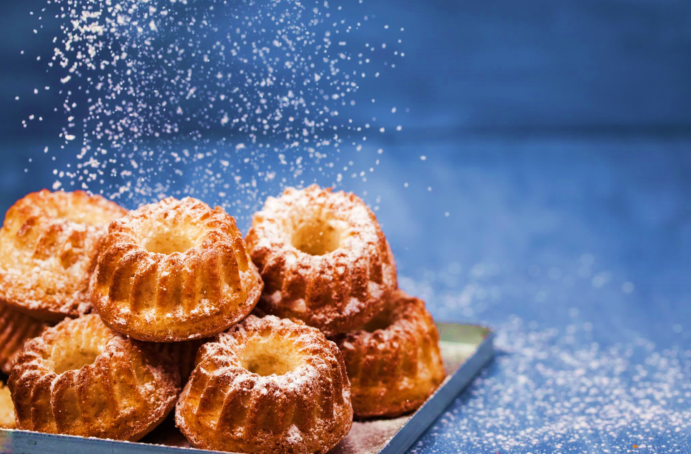

Procedure

Cake recipe

Incrediens:

**1 a glass of oil**

**2 eggs**

3 spoons of cocoa

**4 cup caster** **sugar**

**packet vanilla sugar**

**5 cups all-porpuse flour**

**6 cups all-porpuse flour**

**7 pack loosen powder**

**cup of warm watter**

1. Crack the eggs and separate the yolks from the whites.

2. Mix all the loose ingredients together.

3.Add three egg yolks, a glass of oil and warm water. We will mix all together. Beat the whites until stiff and mix into the dough. To taste, we can add raisins, nuts or coconut.

4.Pour about 2/3 of the dough into a greased and floured mold.

5.Place the cake in the preheated oven and bake for the first 20 minutes. at 150-160 degrees Celsius. Then add to 180 degrees Celsius and finish baking for about 20-30 minutes. We test with a skewer if it is ready inside.

6.Turn out the baked cake, sprinkle with sugar and serve